**Lab 3 Report**

**Title:** Find the best routes with my network dataset

**Notice:** Dr. Bryan Runck

**Author:** Liang-Ting Chen

**Date:** Mar 28, 2021

**Project Repository:**

<https://github.com/chen6761/GIS5572>

**Abstract**

In the lab, I use two different network datasets to find the best route for two vehicles to visit 10 stops. One network dataset is created by Esri, and the other one is built by myself. To meet the requirement of the instructor, I need to set the arrival times and avoid highway constructions. In the end, I discuss the difference between the two results and find how complicated to make a network dataset.

**Problem Statement**

I need to create my network dataset and use it as the vehicle route.

|  |  |  |  |  |  |  |
| --- | --- | --- | --- | --- | --- | --- |
| **#** | **Requirement** | **Defined As** | **Spatial Data** | **Attribute Data** | **Dataset** | **Preparation** |
| 1 | Build Network Dataset | Raw input from MN Geo | Road Centerlines |  | [MNGeo](https://gisdata.mn.gov/dataset/us-mn-state-metrogis-trans-road-centerlines-gac) |  |

**Input Data**

In the lab, I used the road centerlines as the basic data to create the network dataset.

|  |  |  |  |
| --- | --- | --- | --- |
| **#** | **Title** | **Purpose in Analysis** | **Link to Source** |
| 1 | Road Centerlines | As the basic input of building network dataset | [MNGeo](https://gisdata.mn.gov/dataset/us-mn-state-metrogis-trans-road-centerlines-gac) |

**Methods**

**ArcPro**

To create my network dataset, I referred to the steps in the Esri document. ((Create a Network Dataset—ArcGIS Pro | Documentation, n.d.)) The tutorial included the signposts, walking pathways, vehicle height limitation, and unpaved way data. I tried to find some detailed data like it used but failed. So, I used the road centerline data instead and set the basic information to build one.

In my network dataset, I only considered the vehicle, so I ignored the walking pathways. I used elevation fields to make sure of the vertical connectivity. (Figure 1)

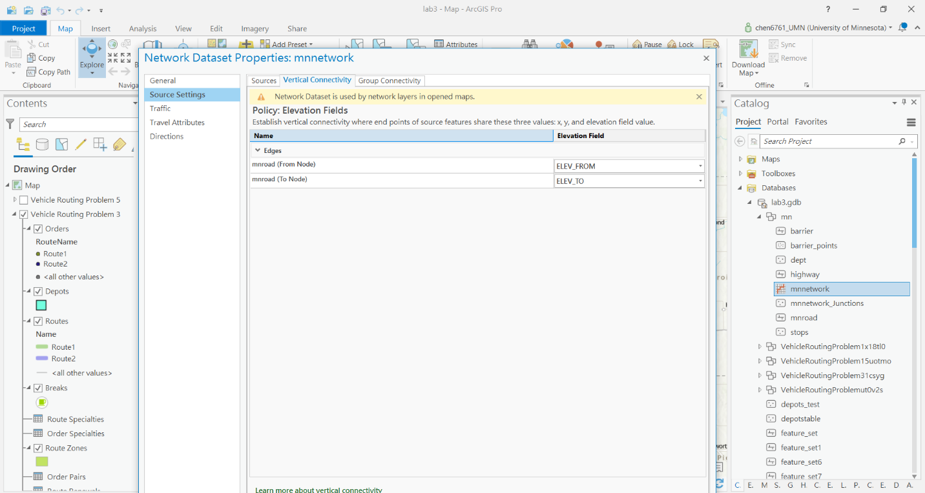

Figure 1

For the restrictions, I made “Construction” and “Oneway”. In the setting of Oneway, I used the filed script type to set the prohibited. (Figure 2) The original attribute included the ONEWAY filed with N, T, and F to help me distinguish the direction.

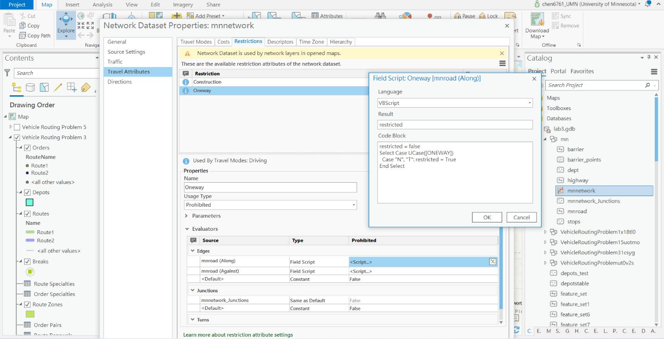

Figure 2

I also built the “Construction” restriction to make the routes avoid highways 94 and 35W. I created a new field in the attribute table named “Construction”, and I filled it with 1 and 0 depending on the row was highway 94 / highway 35W or not. Then, I used the same way in building the “Oneway” restriction that I made the filed script type to set the prohibited.(Figure 3)

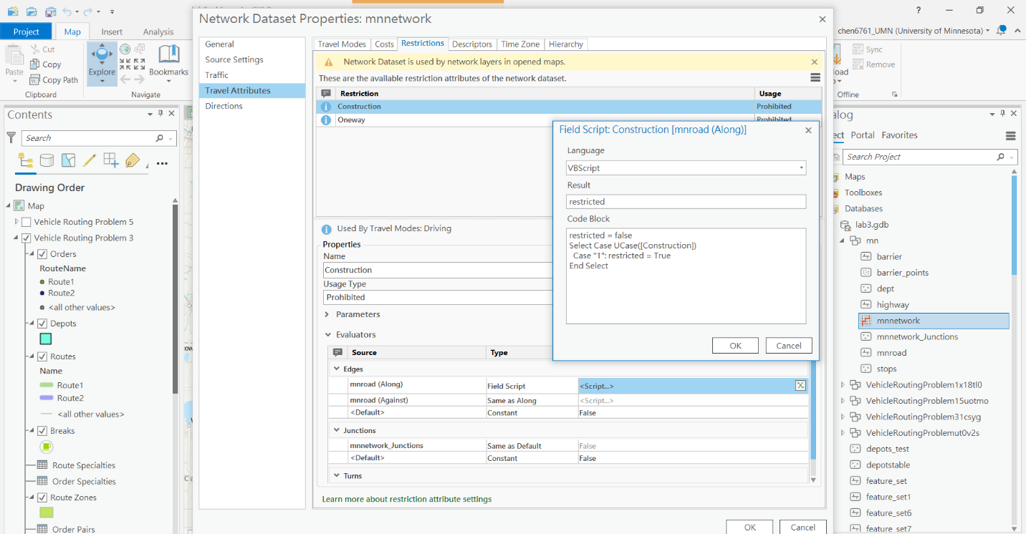

Figure 3

About the cost, I calculated the time with “Shape Length” (meter) and “RouteSpeed” (mph) data. I created a new field “Min” by using “Shape_Length” * 0.000621371 / “ROUTESPEED” * 60. (1 meter = 0.000621371 mile) Then, I set the cost as “Min”. (Figure 4)

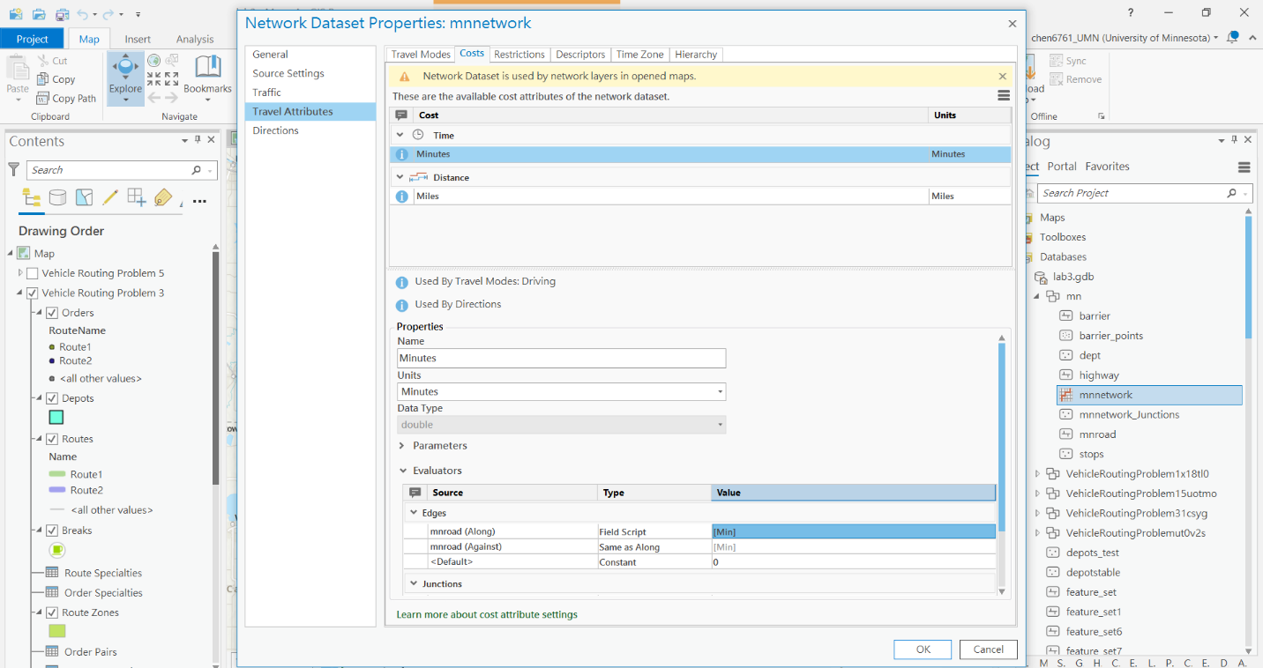

Figure 4

To find the route, I used the Vehicle Routing Problem under the Network Analyst and referred to the steps in the Esri tutorial. ((Service a Set of Orders with a Fleet of Vehicles—ArcGIS Pro | Documentation, n.d.)) To fill the input, I created two points features first. One was the 10 stops, and the other was the start/endpoint. To make sure the route avoided highway 94 and highway 35W, I also created a line feature by selecting that two highways as the barrier. (Figure 5) Then, I added two routes, modified the time to make it meet the requirement, and ran the Vehicle Routing Problem analysis.

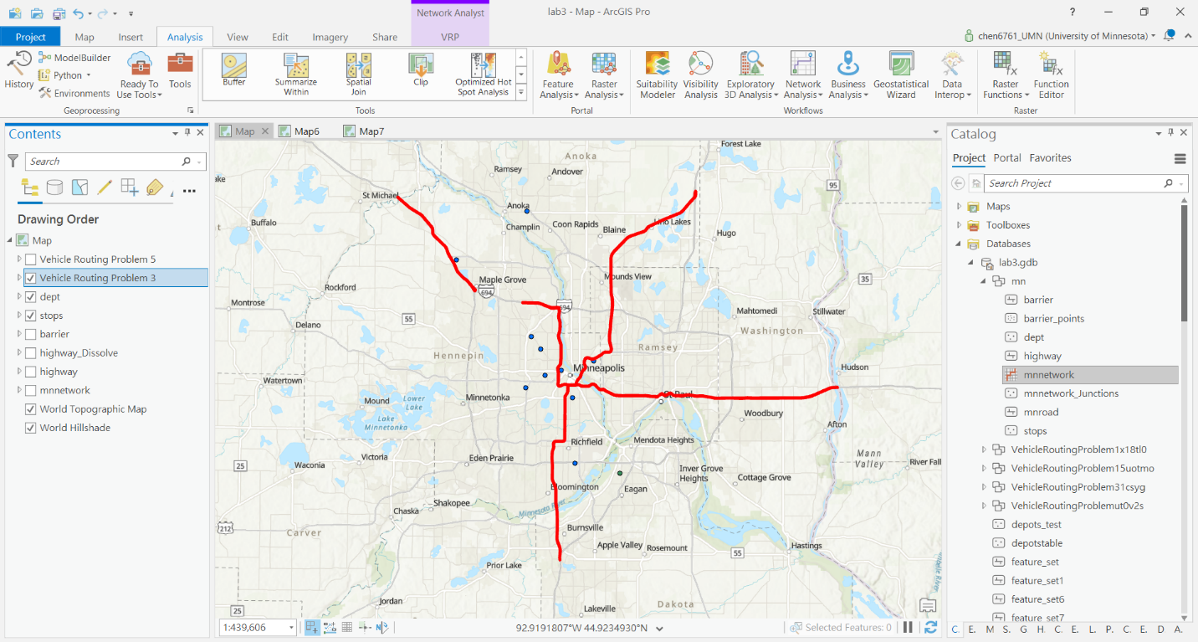

Figure 5

**ArcOnline**

In this part, I uploaded two point feature layers (stops and depot) and one line feature layer (highway barrier) to my ArcOnline content first. Then, I used its “Plan Routes” analysis to find the two routes. However, I found that the line barrier did not work here because of the limited intersection. I eliminated the unnecessary part of the barrier but it still included too many intersections when analyzing. (Figure 6)

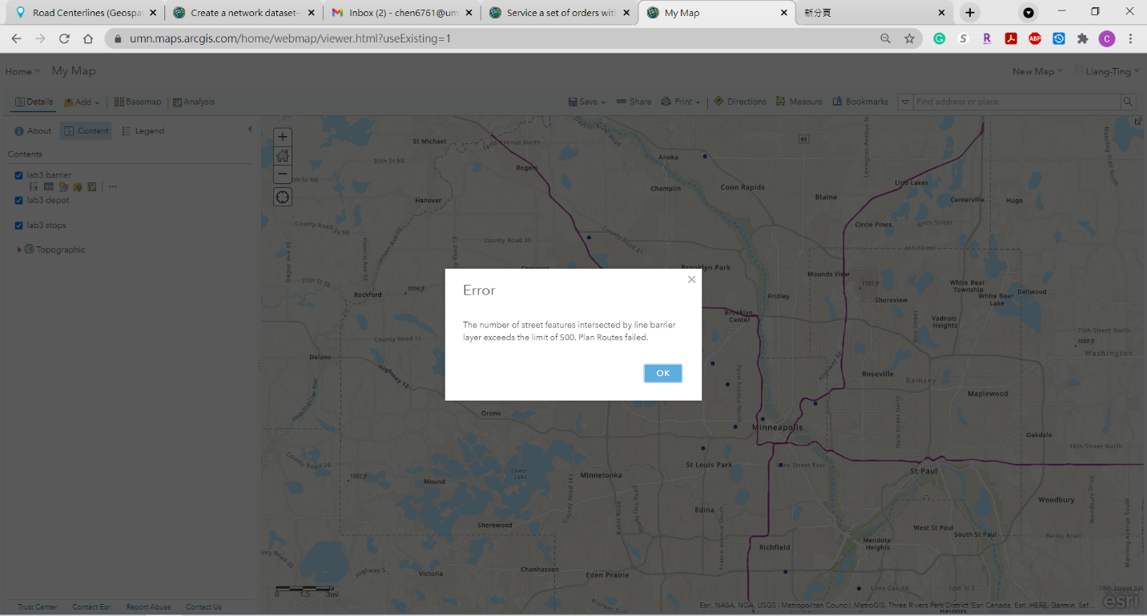

Figure 6

To make it easier to modify the barrier, I changed back to ArcGIS Pro, but I still used the network data source from Esri to compare the result with my network dataset. (Figure 7)

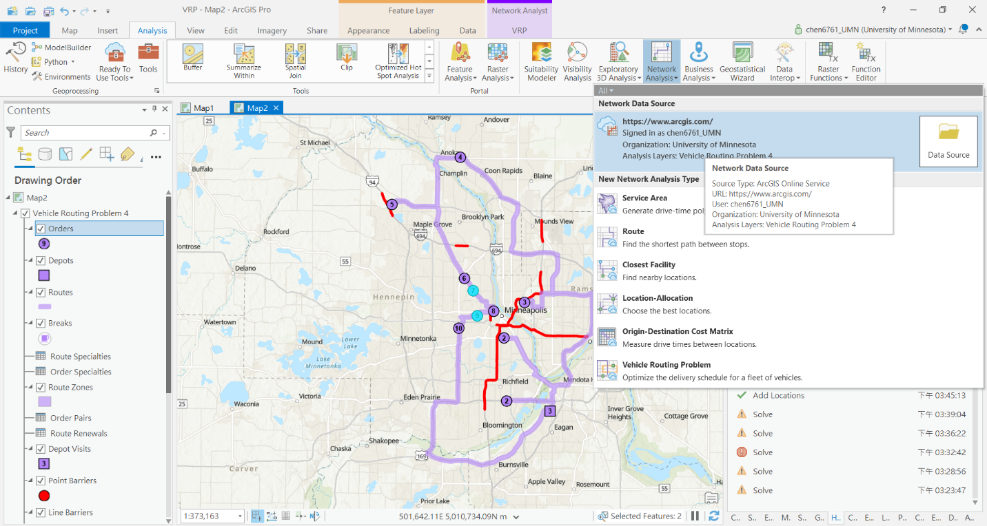

Figure 7

To reduce the intersections between the barriers and streets, I eliminated the unnecessary barrier parts. I also set the start time for the two stops that needed to be arrived between 10 am to 11 am. (Figure 8) Then, I ran the analysis to get the result.

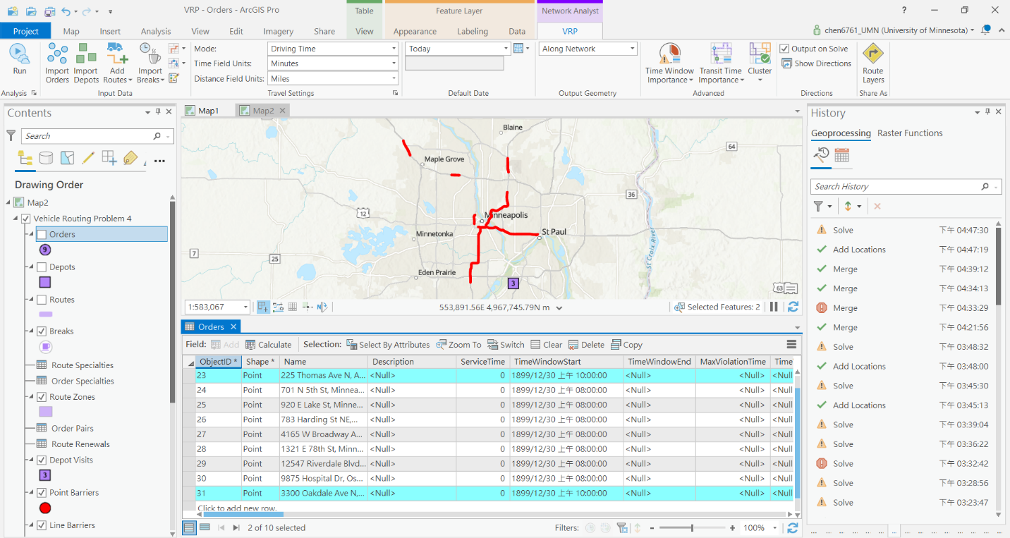

Figure 8

**Results**

**ArcPro**

I exported Highway 94 and Highway 35W as a line layer as the barrier (red) when exporting the routes based on my network dataset. The routes (green and blue) avoided all the constructions area, met all the stops, and returned to the start point. (Figure 9)

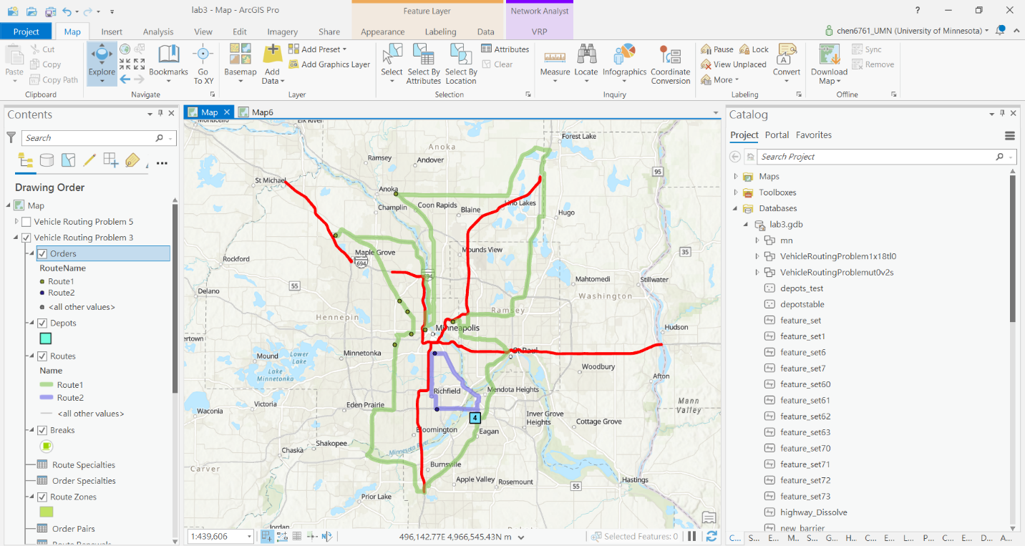

Figure 9

**ArcOnline**

The result shows two routes (blue and pink) without using highway 94 and highway 35W. The two stops also arrived at the scheduled time. (Figure 10)

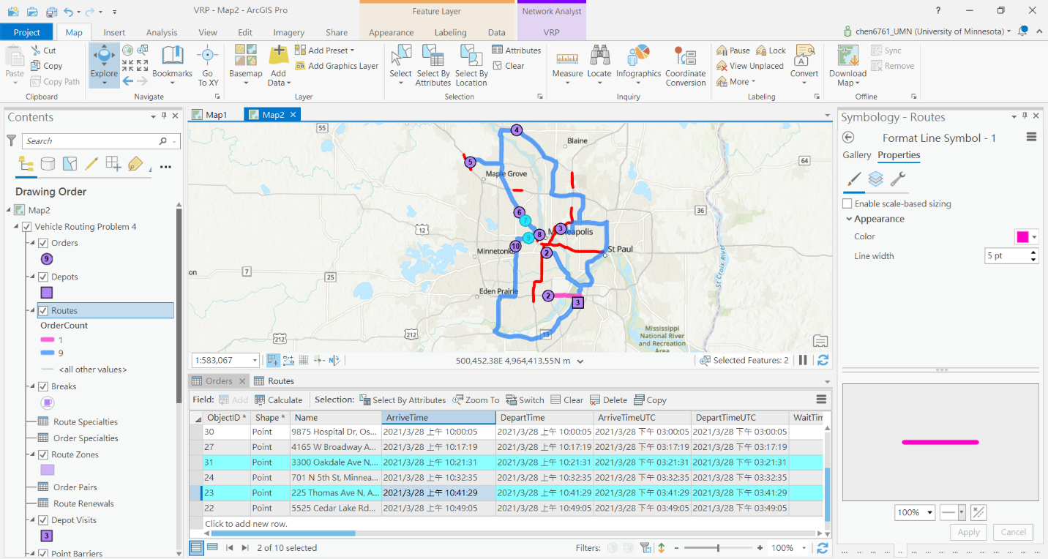

Figure 10

**Results Verification**

**ArcPro**

I found something interesting in the result that it assigned 8 stops for a route (green) and 2 for the other one (blue). (Figure 11)

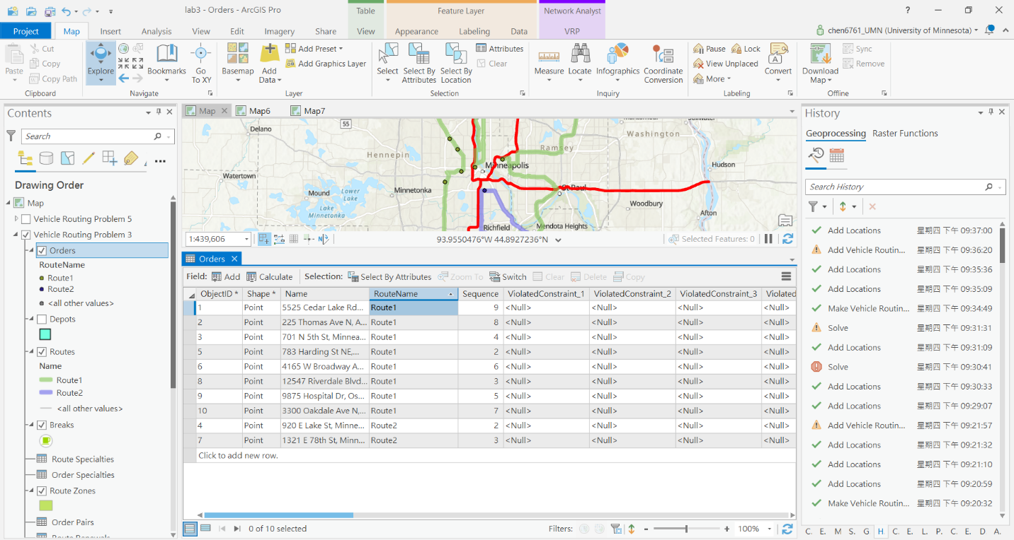

Figure 11

To make sure the other requirements were met. I checked the arrival time and found it matched the requirement about two stops that needed to arrive between 10 to 11 am. (Figure 12)

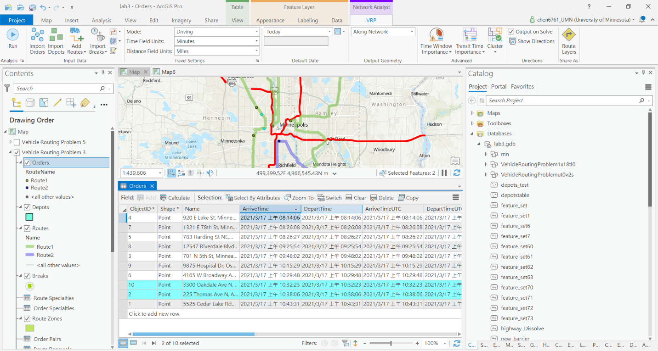

Figure 12

 The total travel time is 205 min for one route and 32 min for the other. (Figure 13)

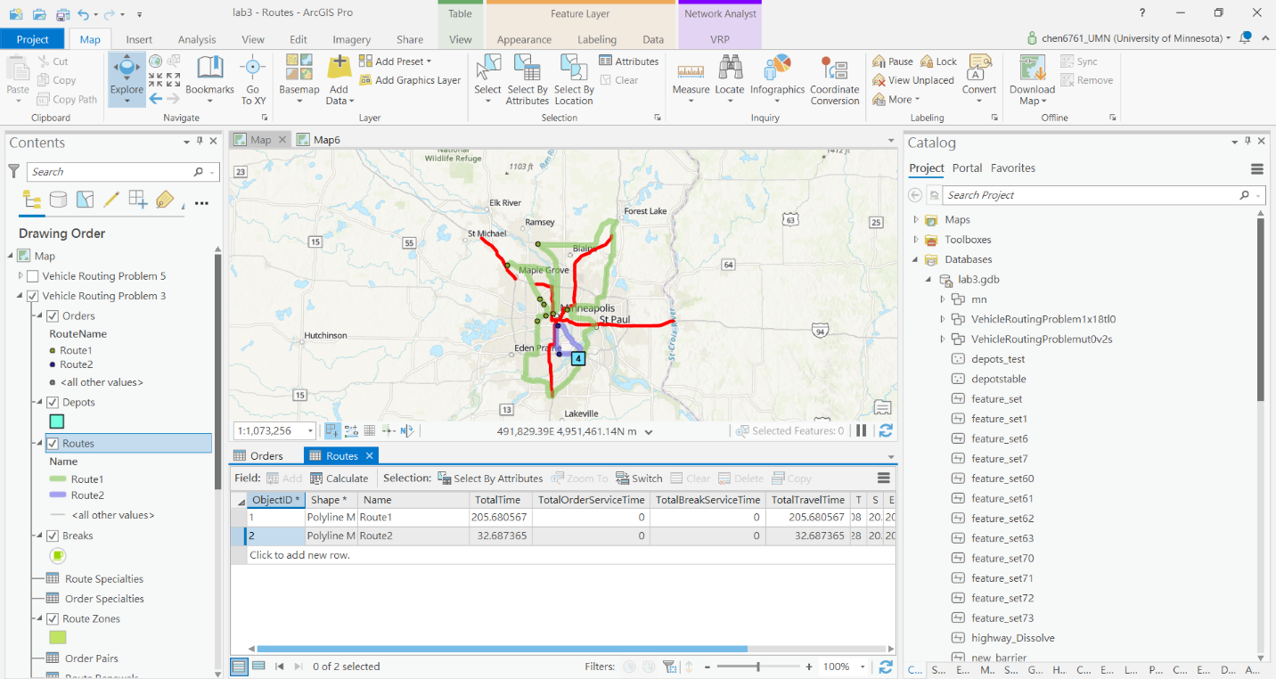

Figure 13

I also tried to limit the stops for each route to see if the total time would reduce but it did not. The total travel time is 206 min for one route and 141 min for the other. (Figure 14)

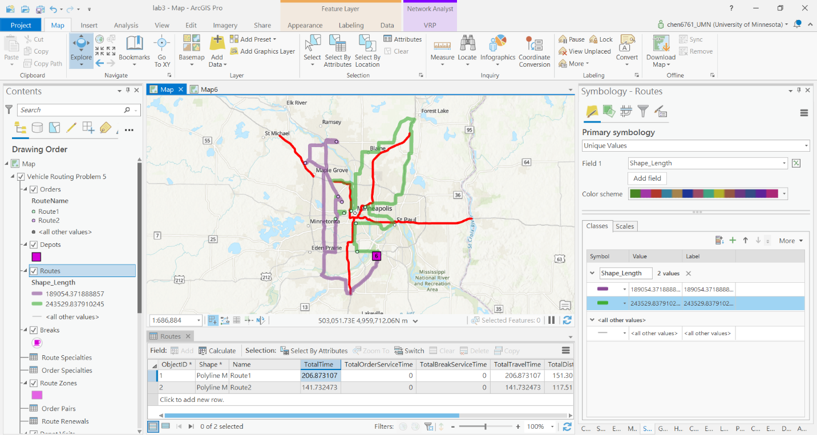

Figure 14

Above all, I think my routes are correct in that it meets the requirement and use the less time to arrive all the stops.

**ArcOnline**

The routes based on Esri’s network dataset used only 225 minutes to finish the delivery. However, the routes analyzed from my network dataset cost 237 minutes to finish. Besides, it assigned 9 stops to a route and 1 stop to the other. This can reduce the labor cost that one of the couriers could only work for less than 20 minutes.

**Discussion and Conclusion**

The lab makes me understand more about the usage of vehicle routing solving functions in ArcGIS. It is a powerful and practical analysis that can promote our daily life. During the lab, I had tried many times to solve the routing problem. I found that the resulting route could be more efficient if it only had one person to deliver because the stops were not so far from each other, and two stops needed to arrive at a specific time. The courier could leave them as the last stops and finished the other stops first. That would reduce the labor cost and only increase few minutes of delivery time eventually.

**References**

*Create a network dataset—ArcGIS Pro | Documentation*. (n.d.). Esri. https://pro.arcgis.com/en/pro-app/latest/help/analysis/networks/how-to-create-a-usable-network-dataset.htm

*Service a set of orders with a fleet of vehicles—ArcGIS Pro | Documentation*. (n.d.). Esri. https://pro.arcgis.com/en/pro-app/latest/help/analysis/networks/service-a-set-of-orders-with-a-fleet-of-vehicles.htm

**Self-score**

|  |  |  |  |
| --- | --- | --- | --- |
| **Category** | **Description** | **Points Possible** | **Score** |
| **Structural Elements** | All elements of a lab report are included **(2 points each)**:  Title, Notice: Dr. Bryan Runck, Author, Project Repository, Date, Abstract, Problem Statement, Input Data w/ tables, Methods w/ Data, Flow Diagrams, Results, Results Verification, Discussion and Conclusion, References in common format, Self-score | 28 | 27 |
| **Clarity of Content** | Each element above is executed at a professional level so that someone can understand the goal, data, methods, results, and their validity and implications in a 5 minute reading at a cursory-level, and in a 30 minute meeting at a deep level **(12 points)**. There is a clear connection from data to results to discussion and conclusion **(12 points)**. | 24 | 23 |
| **Reproducibility** | Results are completely reproducible by someone with basic GIS training. There is no ambiguity in data flow or rationale for data operations. Every step is documented and justified. | 28 | 26 |
| **Verification** | Results are correct in that they have been verified in comparison to some standards. The standard is clearly stated **(10 points)**, the method of comparison is clearly stated **(5 points)**, and the result of verification is clearly stated **(5 points)**. | 20 | 19 |
|  |  | 100 | 95 |